**Game Design of Greek Pong**

**Introduction:**

My project is based on “Battle Pong”.

<http://www.miniclip3000.com/miniclip-Battle-pong-10.html>

It is a game that is similar to pong with 2 paddles but includes weapons.

The theme is greek mythology. Hence the name, “Greek Pong”.

There are 3 characters to choose from; Zeus, Hades and Poseidon. There is a unique paddle for each one. In the beginning of the game you will be able to select the God. All gods have 5 common weapons in addition to one unique super weapon per god.

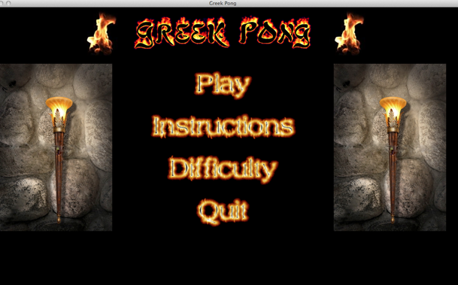

**Module:**

I am using pygame for my project. It is very easy to install. It is built into python. So all that needs to be done is install python and import pygame.

I am using pygame because it is very easy to use as it has a lot of built in functions. Images are extremely easy to work with as well.

**Difficulty:**

This game is relatively difficult to play as the skills must be mastered to play. It is fast to pick up but also needs practice. Using the weapons and collecting them as well as the powerups needs some getting used to.

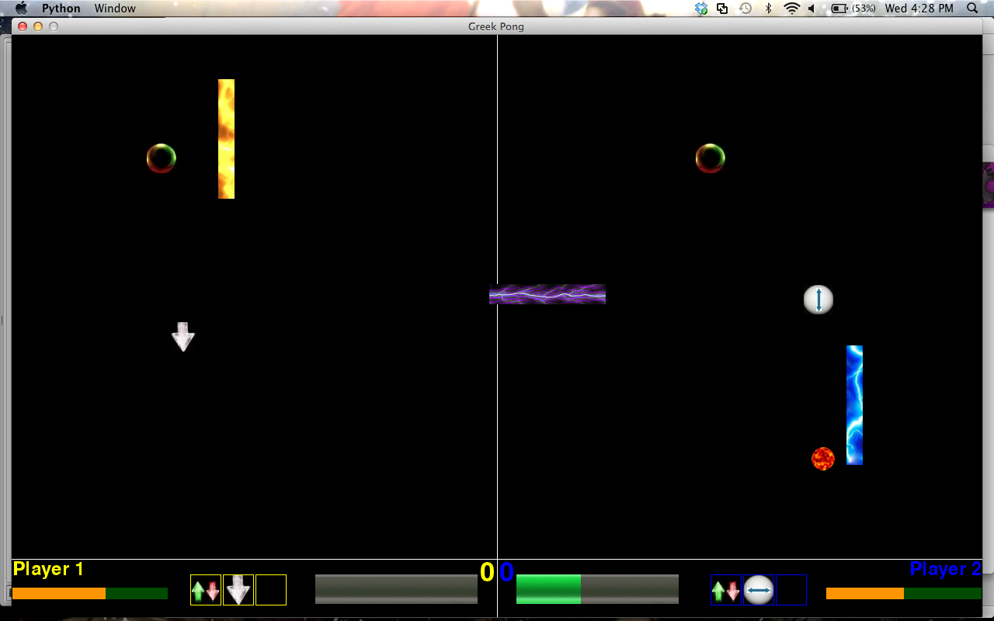

**SuperWeapons:**

The superweapon concept is something I introduced into the game apart from the normal weapons. It is a system where in addition to all the normal weapons, each god has a super weapon that they can use if their super power bar is full.

Zeus: Zeus has a homing missile as a super power.

Hades: Hades makes the ball invisible as it goes toward the opponent.

Poseidon: Poseidon restricts the opponents vertical movement.

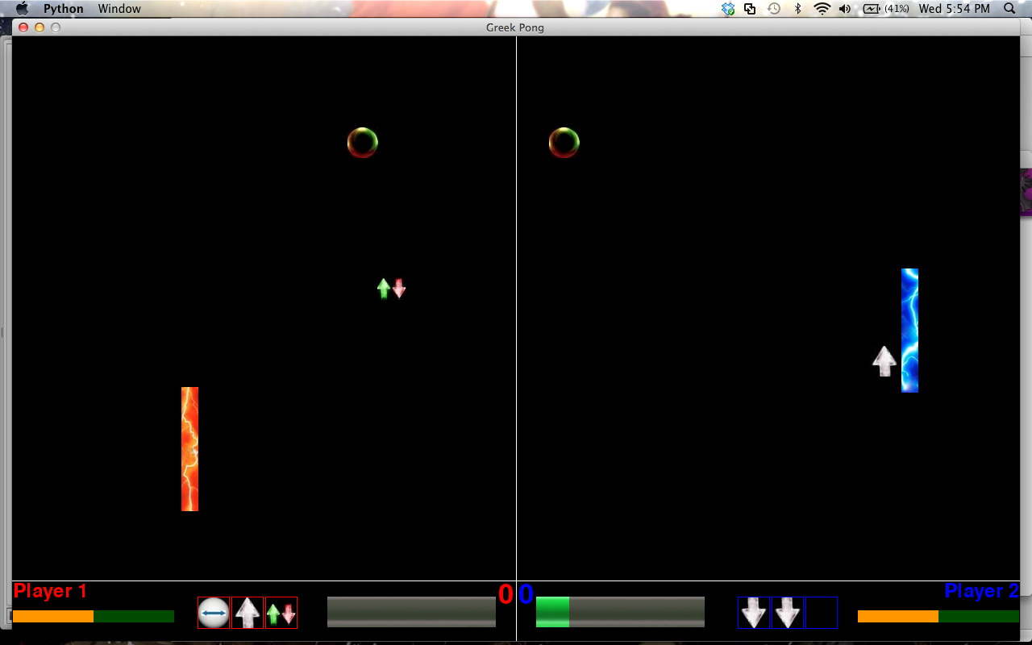

Hades made the ball invisible when it goes towards the opponent.

**Comparison With Similar Game:**

The Game I got the idea for my game from is Battle Pong by Miniclip.

I have always like Greek Mythology and hence adapted the game to a Greek theme. I designed my Graphical User Interface for easy and logical access to instructions and difficulty etc. I also tried to make it look as good as possible.

Many of my weapons are similar to the ones in the miniclip version of the game. The way weapons are obtained however is very different. The paddles must go to the weapon to collect it as opposed to hitting the ball on a specific region of the wall as in the miniclip version.

A major change I made to the game was the movement of the paddles. In the miniclip version, the paddles were only allowed to move in the vertical axis.

In my game, I made it possible for the paddles to move in all directions which opened my game up to a lot more possibilities.

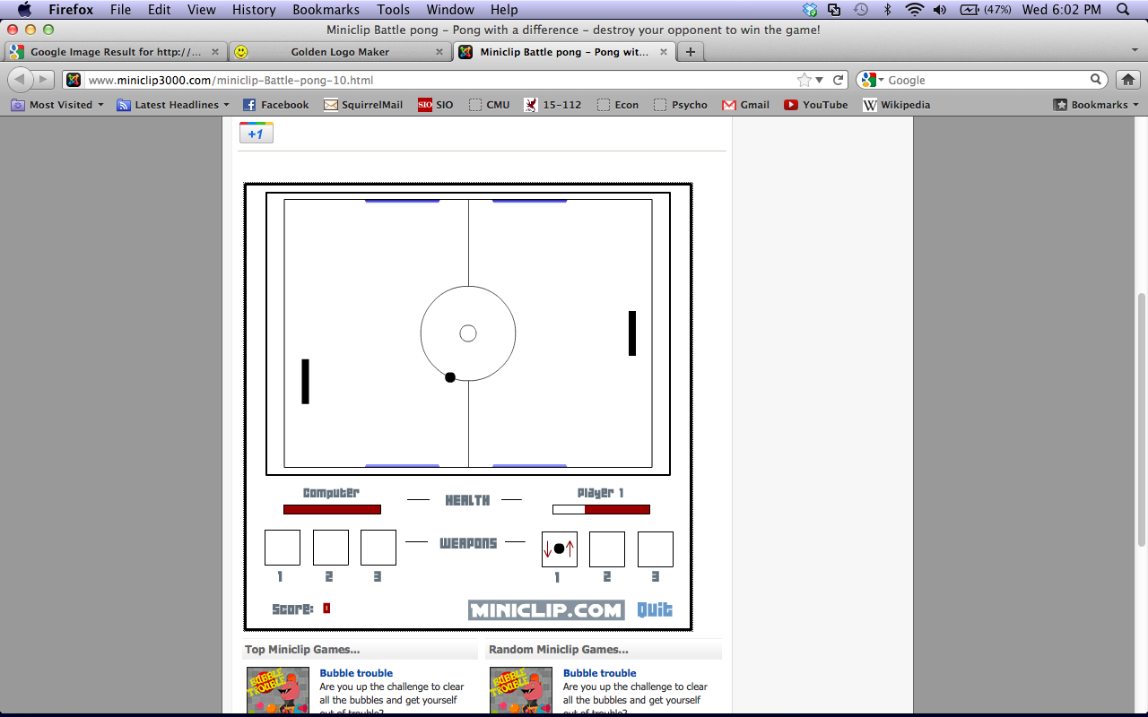

Another new concept is the **super-weapons**:

The reason that the choice of characters matters is that each one has a different super weapon. This is absent in the miniclip version. It affects the play style of the player.

**General User Interface**

I used a lot of images in my game. I had to look for hours for good images that fit in with my theme of the game. I then had to crop and scale all images to fit in. This was very difficult to do as I wanted the images to be perfectly set up in my game without being asymmetrical or have any other such glitches that makes the game looks shabby.

**Obstacles Faced:**

The flames that are present in the menu screen took me a long time to code in. The solution that I found was relatively easy to implement. I took an image that contained 16 different stages of the flame. I tried to crop them all the same size. This task is near impossible. I then looped through all the images. The flame looked like it was moving upwards.

Therefore I continued my search in something that would help me. After a long time of searching, I found a pygame function that allowed me to crop images ingame. This is called subsurfacing. Using subsrufacing, I was able to continuously crop images from the main image. I thought of the main image as a 4 by 4 grid. I then looped through it loading the images at certain intervals making it look like an animated flame.

Another obstacle I faced was the homing missile for Zeus. I wanted to make it such that the missile could be avoided. After thinking about I came up with the solution. The missile has a set horizontal speed and vertical speed. However, the missile’s vertical speed is less than that of the paddle. The paddle will move upwards if the enemy paddle is above it and the other way if it is below. In this way it does not move as fast as the paddle but still tracks it. Therefore it is possible to avoid the missile.